
RCS Operation Guideline
Date: 19 March 2024
Version: V2

Ref:

Table of Contents
1. Versions 3
2. Objective 3
3. Postman 3
Ticket Creation 3
Fetch Emails to RCS Tickets 4
Redirect Emails to Internal Teams 4
IT Issues for Eik Vessels 4
Assign Emails to Internal Teams 5
Customer Escalation 7
Outage Notification 7
4. Ticket Handling 9
MSS Request Ticket 9
Incident Ticket 9
Transfer to Upper Team 9
Handover 9
5. Ticket Follow-up 10
6. Contracts of Internal Teams 11
7. Appendix. MNOC Operation 12
Postman/Ticket Handling 12

Versions
Author | Date Modified | Changes Made
Guanglin Si | 27th Feb 2024 | Initial version
Guanglin Si | 19th Mar 2024 | Added “Outage Notification”

Objective
The objective of this document is to delineate the operational scope of RCS team and provide guidance to team members. Additionally, it aims to foster effective collaboration and coherence among various teams involved, mitigate confusion, and optimize collective efforts towards our team goals.

Postman

Ticket Creation
Monitor RCS postman (formerly SD postman) and create new tickets for unassigned emails under RCS resource by default. Teams can use filter “Unread without ticket” to filter out such emails.
The person who creates the ticket shall initiate the first response to inform the customer about the ticket creation and then work on the case.
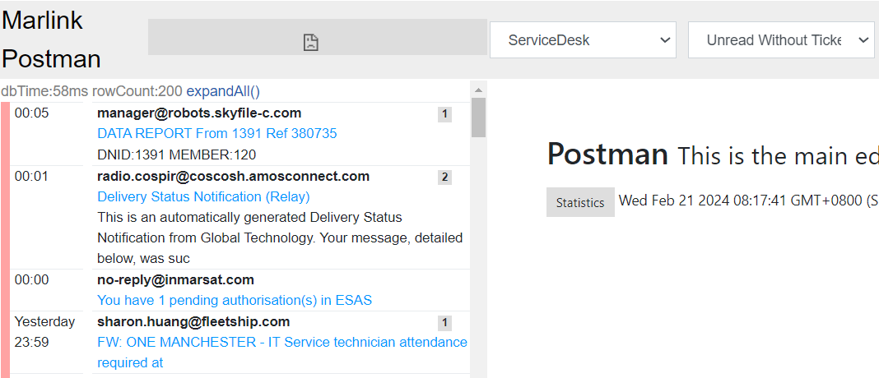
Bratislava/Singapore/US RCS teams shall assign dedicated personal to monitor the postman, targeting to create new tickets within 1-hour TTO time window. Other teams can create new tickets on ad-hoc basis.

Fetch Emails to RCS Tickets
Monitor RCS postman and fetch emails to existing RCS tickets. Color code: pink

Redirect Emails to Internal Teams
If an email is addressed to another internal team, and they are not in the email loop, we can forward to them by below:
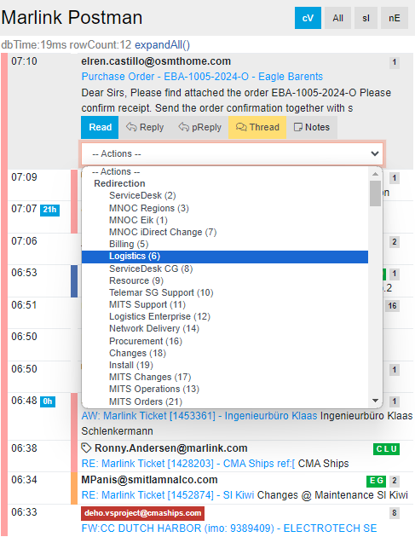

IT Issues for Eik Vessels
Process as below:

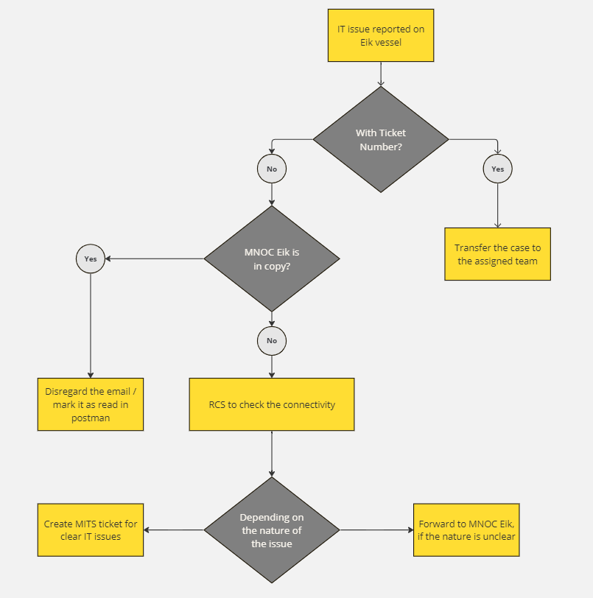

Assign Emails to Internal Teams
If the ticket is already assigned to another team, e.g., MNOC Bratislava, CCTS etc., we should assign the email to them.
Note: the difference between Redirection and Assign is:
Redirection= forwarding an email to an email address, e.g., resource@marlink.com
Assign= assign an email to a resource, who shares the same service desk email with RCS, e.g., MNOC Bratislava and CCTS
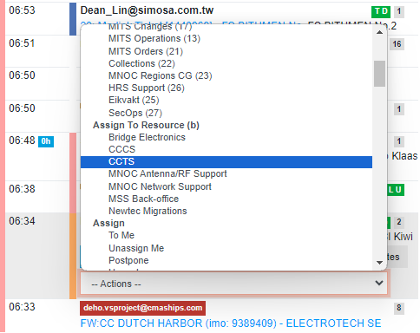

Customer Escalation
Email to escalation@marlink.com is automatically forwarded to RCS postman, as example below. RCS team shall acknowledge on the reception to customer, and forward it to the relevant team. Depending on the case’s severity, RCS may call relevant team on their on-call.
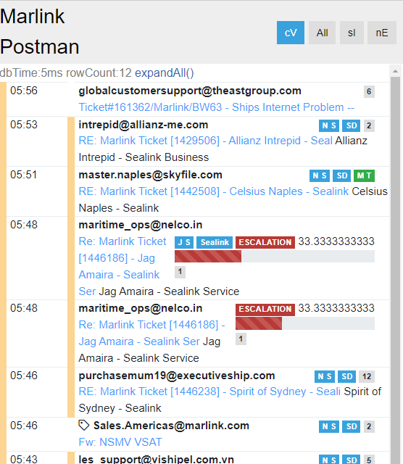

Outage Notification
!! FX and VSAT outages should be handled by MNOC Bratislava. RCS handles other outages, e.g., on MSS or Marlink portals.

Steps:
- Create a ticket under the affected service or site. You can refer to existing notification tickets for reference. E.g., 1484879

- Go to “Backoffice” on Merits, then “Notification: Mailgun Engine”, and click on “New Notification”.
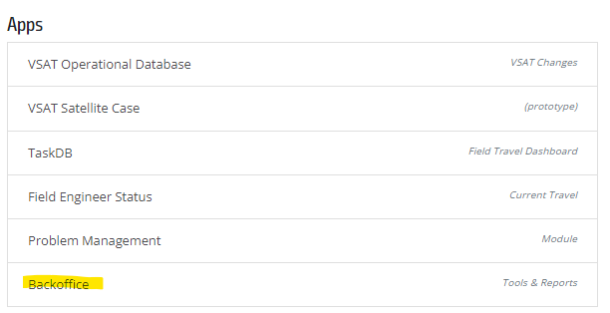
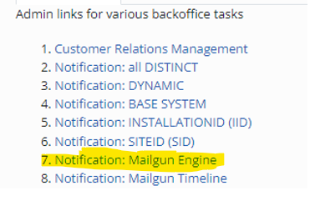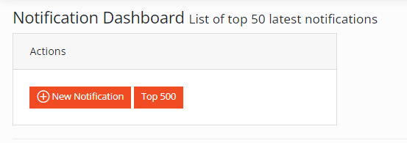
- Select a predefine template under “Subject Templates”, then fill up the details based on the original notification email. Indicate the above created ticket number under “Ticket”.

A preview is displayed on the right.

- You can find the “Email List” from here based on the affected services, as below:
- Click on Save, then “Run Job” and notification will be sent out.
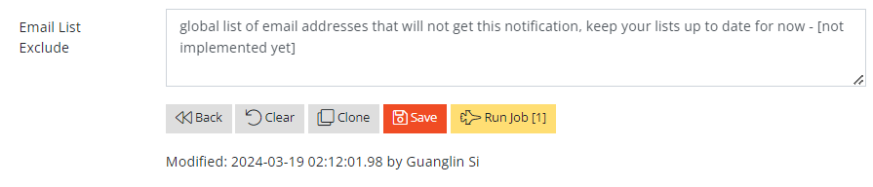

- Assign the ticket to yourself, and close it after the outage ends.

Ticket Handling
Currently the team should work on the tickets in the order to aTTU, or “Ticket Action ASC”, with below filters applied:
- Assigned: “unassigned”
- RCS center: “All”
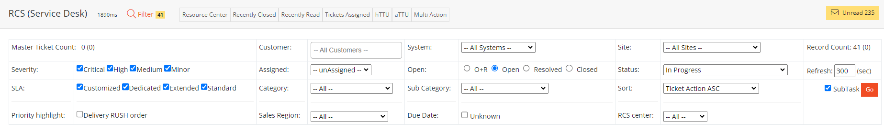

Tickets status must be updated afterwards, e.g., to “waiting for customer”. We should set “auto close” when there is a good chance that customer may not reply to us, e.g., after a beam switching and blockage check.
Key findings in troubleshooting should be captured in ticket notes.

MSS Request Ticket
RCS should validate that the customer has provided the necessary information for activation and deactivation tasks, then forward the ticket to Backoffice team.

Incident Ticket
RCS should follow the scope as defined in Excel matrix, and fulfil the minimum work required before escalating to MNOC Bratislava.​

Transfer to Upper Team
Ticket should be passed to upper team, if it is beyond RCS scope. We should update the customer about the transfer.

Handover
Before the end of their shift, team on-duty shall handover ongoing tickets to other teams in RCS group chat. The ticket status should be set to Handover too per below screenshot.
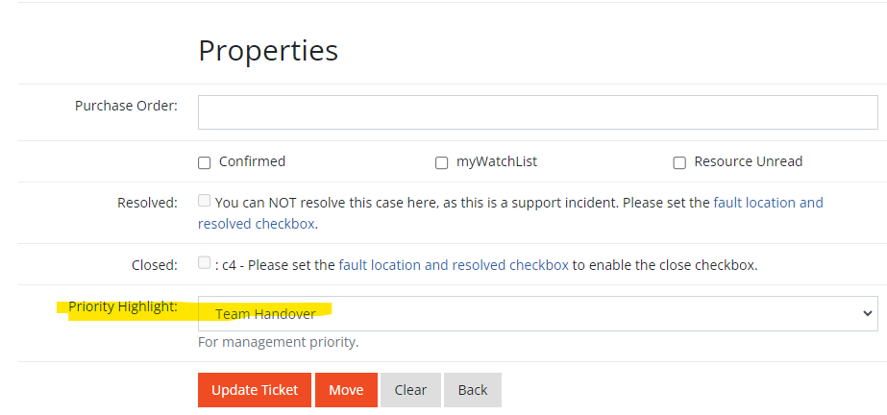

Ticket Follow-up
RCS team should follow up on the open tickets under their corresponding region.
Filters to be applied: RCS center, “incident” “Request” category, ALL resource, “In progress” status.

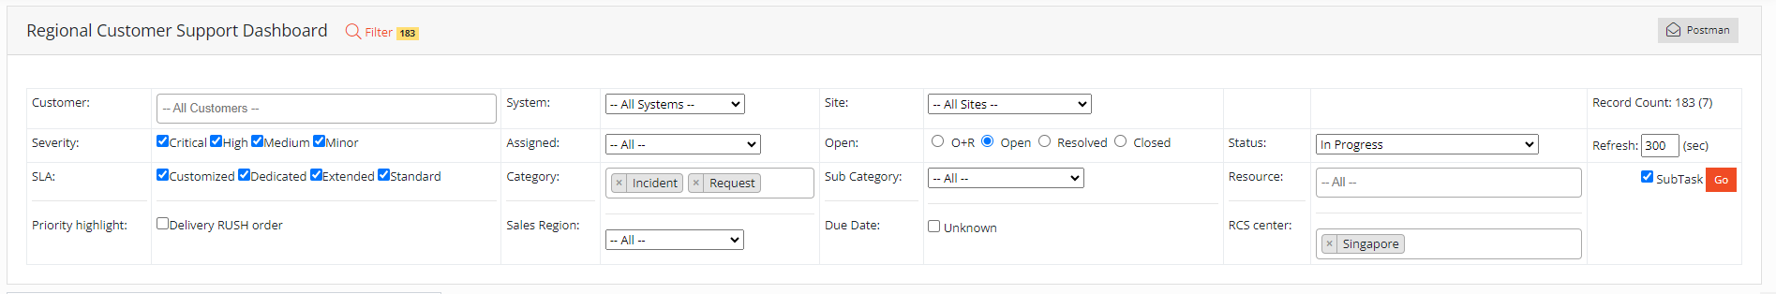

Contracts of Internal Teams
Here are the contacts of our internal teams. In urgent cases, we can either contact the team via phone or escalate to the person-in-charge:

Team | Phone/Escalation Point | Email
Billing | +31 703 00 1818 (option 2) | billing@marlink.com
Bridge Electronics Support |  | support.it@telemargroup.com
CCCS | +33 561 28 8994
CCTS | +33 677 35 6363
Eirvakt | +47 5140 8080
Enterprise | +421 258 262 701 | enterprise.support@marlink.com
HRS | +30 2169 00 0009 | support.hrssatcom@marlink.com
IM | arthur.lambert@marlink.com/  brian.storm@marlink.com | imservicedesk@marlink.com
MITS | 801761 (Trio)
MNOC Brat | 2900 (Trio)
MNOC Eik | 6000 (Trio)
MSS Backoffice | 2901 (Trio)
RCS | 801757 (Trio)
RCS CG | +30 210 94 00377 | servicedesk.cg@marlink.com
Secops | Contact CCTS if urgent | secops@marlink.com
Starlink Activation | mark.pitts@marlink.com | starlinkactivation@marlink.com

Appendix. MNOC Operation
During the transition period, SG and US RCS teams will continue to function as rMNOC, outside MNOC Bratislava’s working hours. This is to be reviewed by 3rd June, when Bratislava is expected to work 24x7.

Postman/Ticket Handling
Select “MNOC Regions VSAT Support” filter in postman, and work on the emails on first-in-first-out basis.
